Git Hands-on 5
Step 1: Verify if the repository is in a clean state
Command Used:
git status
Description:
This command checks the current status of the local repository and verifies whether the working directory is clean.
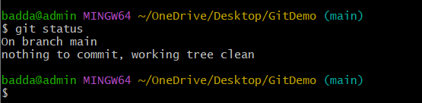

Step 2: List all available branches
Command Used:
git branch
Description:
This command lists all the branches available in the local Git repository.


Step 3: Pull the remote repository
Command Used:
git pull origin main
Description:
This command fetches and merges the latest changes from the remote GitHub repository into the local repository.
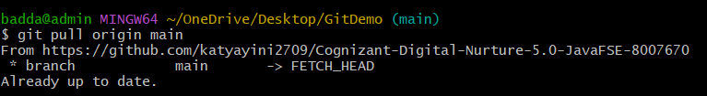

Step 4: Push local changes to the remote repository
Command Used:
git push origin main
Description:
This command pushes the local repository changes to the remote GitHub repository.
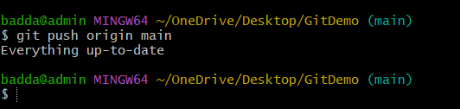
Step 5: Verify the changes in the remote repository
Description:
Opened the GitHub repository and verified that the latest changes were reflected successfully.
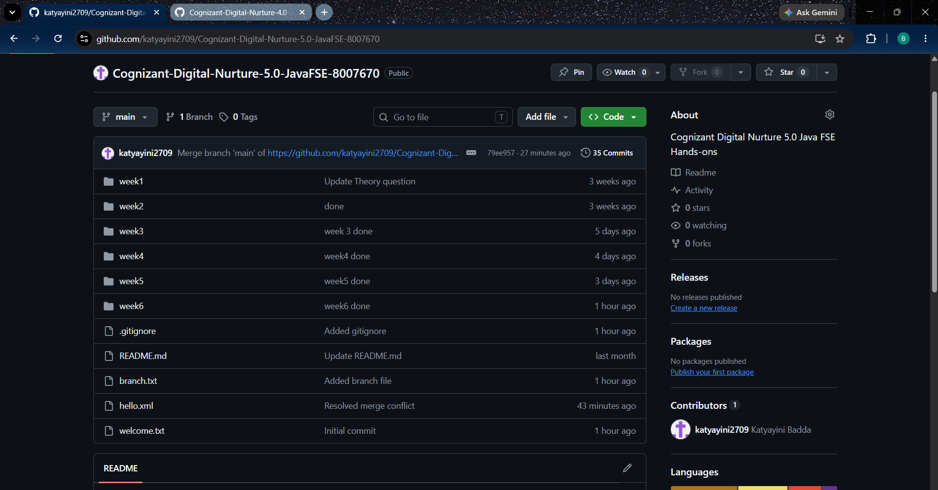
Conclusion
The Git repository was successfully verified, synchronized with the remote repository, and the latest changes were confirmed on GitHub. This completed the clean-up and push-back process.

